Research on the two algorithms, SuperPoint and SuperGlue, and their usage in Project:
SuperPoint Algorithm:
SuperPoint is a deep-learning, neural-network-based feature detector and descriptor extractor.
Definition: SuperPoint is a self-supervised deep learning model designed for keypoint detection and description in computer vision. It identifies salient image points and computes robust feature descriptors without requiring manually labeled data. The method is notable for its speed, accuracy, and wide adoption in tasks like visual odometry, SLAM, and image matching.
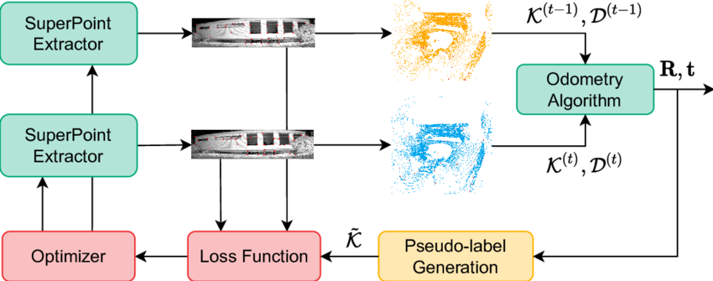
Input to an algorithm:
- A single grayscale image from camera
(example: 640×480 image)
Output to an algorithm:
- Keypoints (2D points)
Example:
(x₁, y₁), (x₂, y₂), …
- Descriptors (feature vectors)
For each keypoint, we get a 256-dimensional vector.
Output is for each image we get keypoints and descriptions of each keypoint.
Algorithm Steps:
SuperPoint works in 3 stages:
Step 1: Feature Detection
- CNN scans image
- Predicts “interest points” probability map
- Extracts strong corner-like points
Step 2: Non-Maximum Suppression
- Removes weak/duplicate points
- Keeps strongest keypoints
Step 3: Descriptor Generation
- For each keypoint
- Extracts 256D feature vector
- Encodes local visual pattern
Flow chart: Image → CNN → Heatmap → Keypoints → Descriptors.
Usage in Our Project
SuperPoint can be used for:
- Visual Odometry
- Dock feature detection
- Ground feature detection
- SLAM feature extraction
It detects:
- Rocks
- Terrain edges
- Surface texture points
- Landing markers.

SuperGlue Algorithm:
SuperGlue is a neural network that matches features between two images.
Definition: SuperGlue is a neural network model for feature matching in computer vision. It establishes correspondences between sets of local features detected in different images, improving tasks such as structure-from-motion, visual localization, and 3D reconstruction.
Input to an algorithm
From two images:
Image A:
- Keypoints A
- Descriptors A
Image B:
- Keypoints B
- Descriptors B
(Usually generated by SuperPoint)
Output to an algorithm:
- Matched keypoint pairs
- Example:
Image A point (120,45) ↔ Image B point (130,50)
Image A point (220,80) ↔ Image B point (230,90)
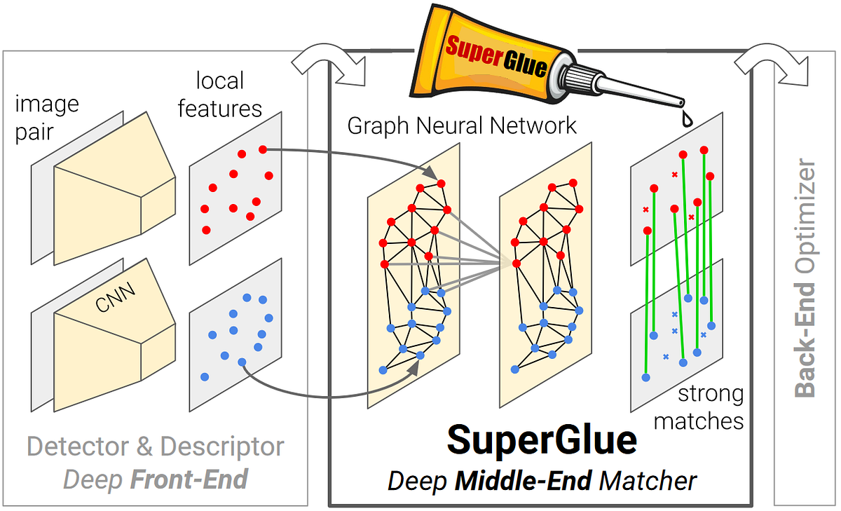
Algorithm Steps:
Step 1: Build Graph
- Treat keypoints as nodes
- Build relationships between them
Step 2: Attention Mechanism
- Neural network compares all features
- Understands spatial consistency
Step 3: Matching Score Computation
- Computes probability of correct match
Step 4: Optimal Assignment
- Selects best match pairs
- Rejects outliers
Summary of algorithm(how it actually works):
Descriptors A + Descriptors B
→ Graph Neural Network
→ Matching Confidence
→ Final Correspondences

After SuperGlue gives matched points:
We compute:
- Essential Matrix
- Pose estimation
- Relative camera movement
This gives:
Δx, Δy, Δz, rotation
Which helps estimate drone motion.

Are they 2D or 3D:
SuperPoint: Detects 2D image features
SuperGlue: Matches 2D features
But when combined with:
- Depth (LiDAR)
- Multi-view geometry
You get 3D pose estimation.
How They Fit to our Project:
For GNSS-denied aerial scout:
They can be used for:
- Visual Odometry: Estimate movement between frames
- Dock Detection: Precisely align with docking station
- Loop Closure: Correct accumulated drift
- Terrain Feature Recognition: Match ground textures across passes

